Divis Community Centre
Address: Ardmullen Street, Belfast, BT12 4RT
Call the Open Arts office number directly for venue and classes information: 028 90 240765
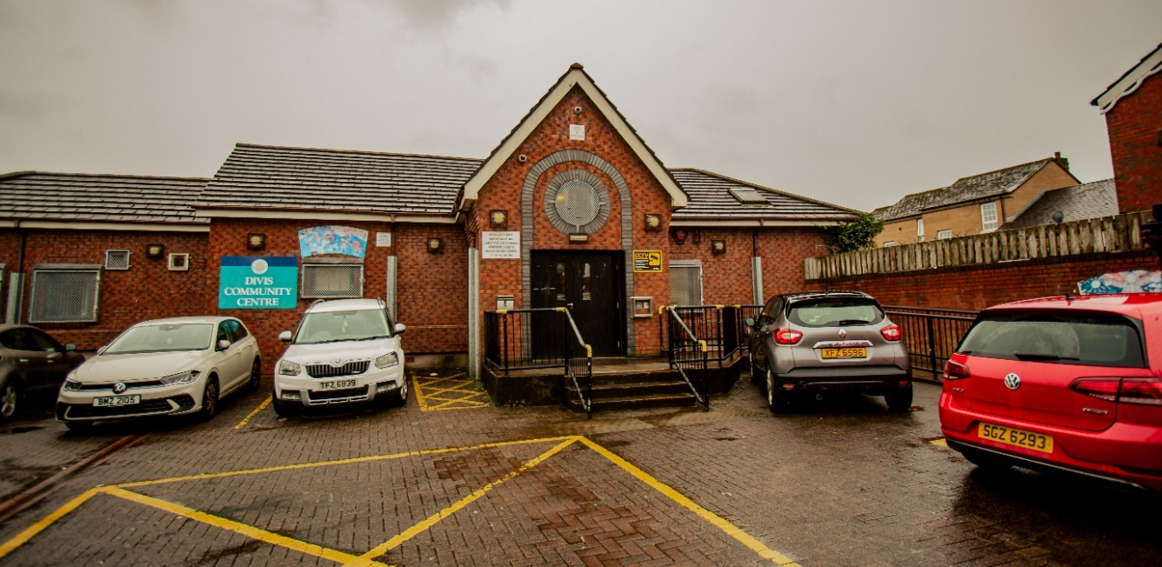

Getting Here
Gilder G1 West – Divis Tower stop is 2 mins walk from Divis Community Centre. Leaves from College Square East, located in front of the Royal Belfast Academical Institution (Belfast Inst).
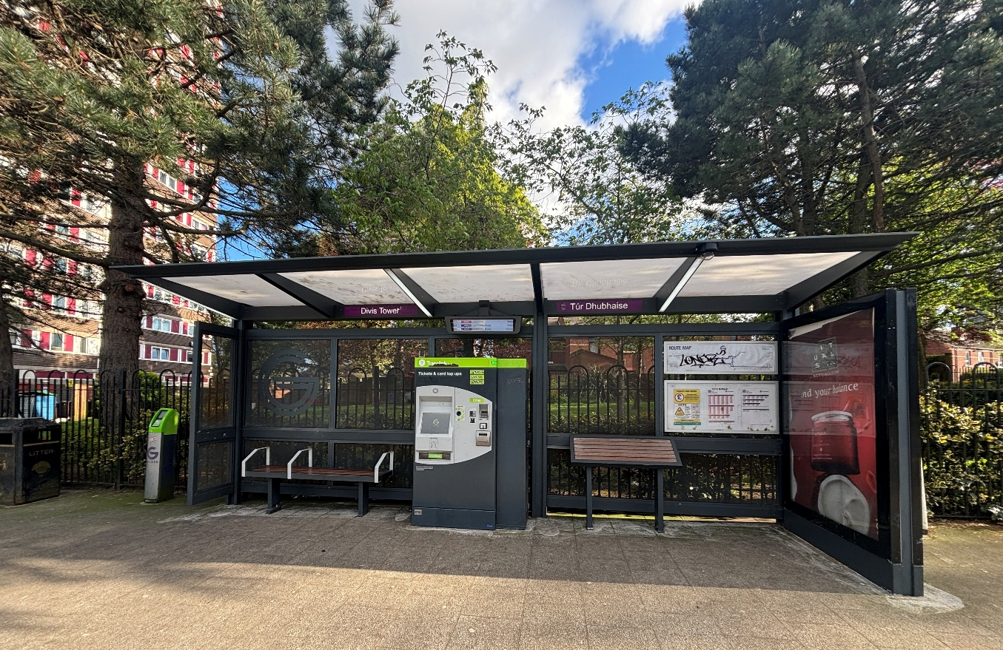
Metro Bus – Service number 10 which leaves from Queens Street in City Centre.
Car parking – Two disabled parking spaces are available in the main car park (limited availability). Additional parking is available at the rear entrance, with on-street parking nearby.

Entrance
The building has both step and ramp access.
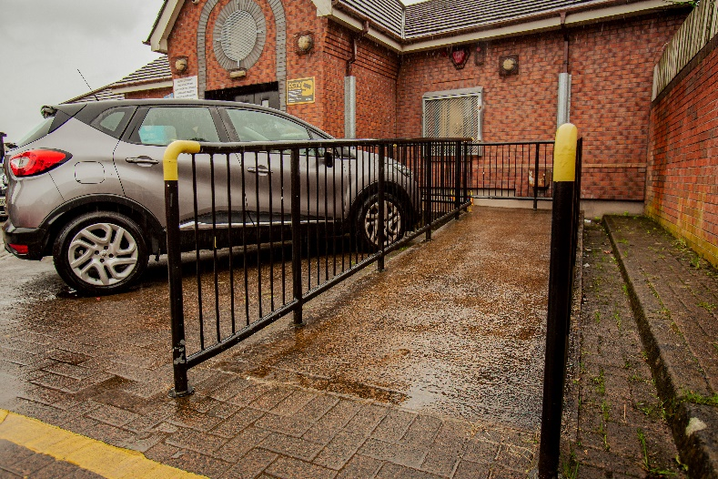
Reception
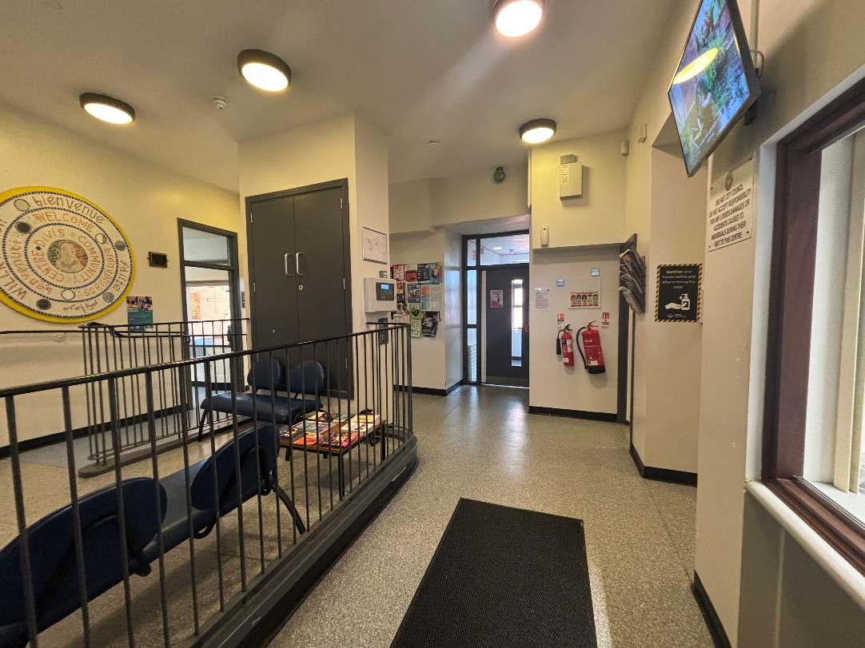
Toilets
There are accessible toilets on both levels of the building. 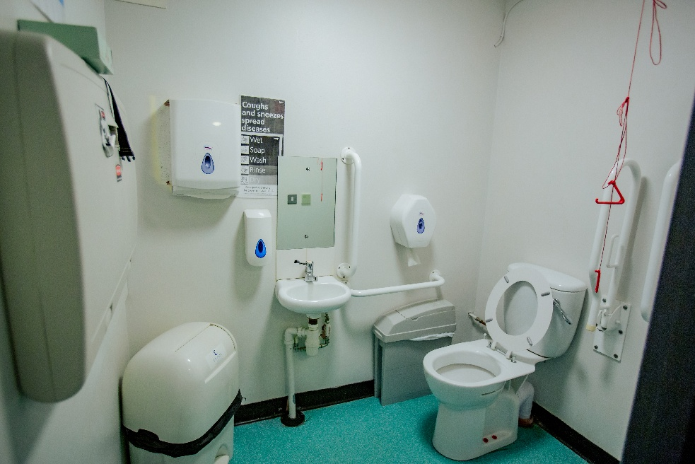
Ground Floor – Men’s, Ladies and accessible toilets
Lower floor – Men’s, Ladies and accessible toilets. Can be accessed via the lift located in reception or main staircase.
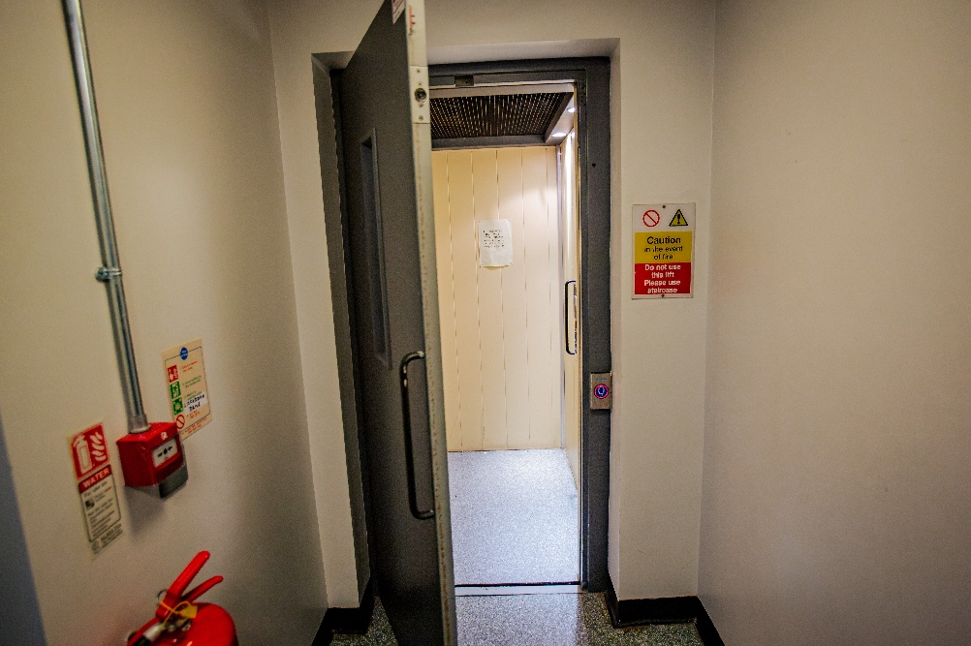

Open Arts Community Choir
When: Weekly on Monday 7pm-9pm.
Where: The class is located in the Main Hall, on the ground floor.
Main Hall room:
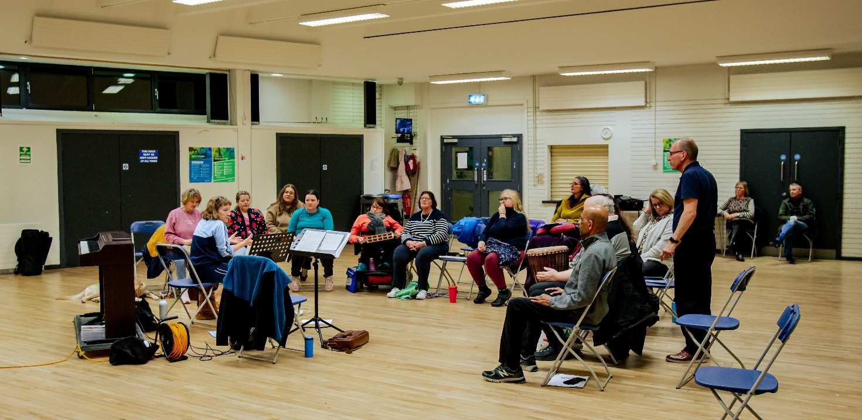
Facilitators
The choir is facilitated by Alan Beattie and guest choral musicians.
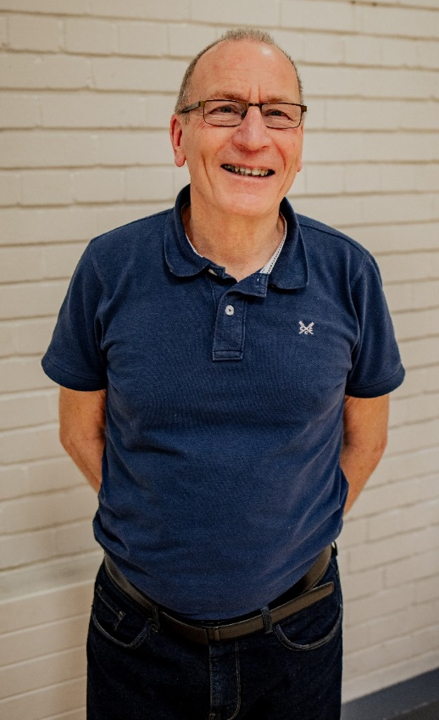

Acorn Art Group
When: Weekly Thursday 10am-12pm
Where: The class is located on the lower floor, which is accessed via stairs or a lift on the ground floor near reception.
Workshop room:
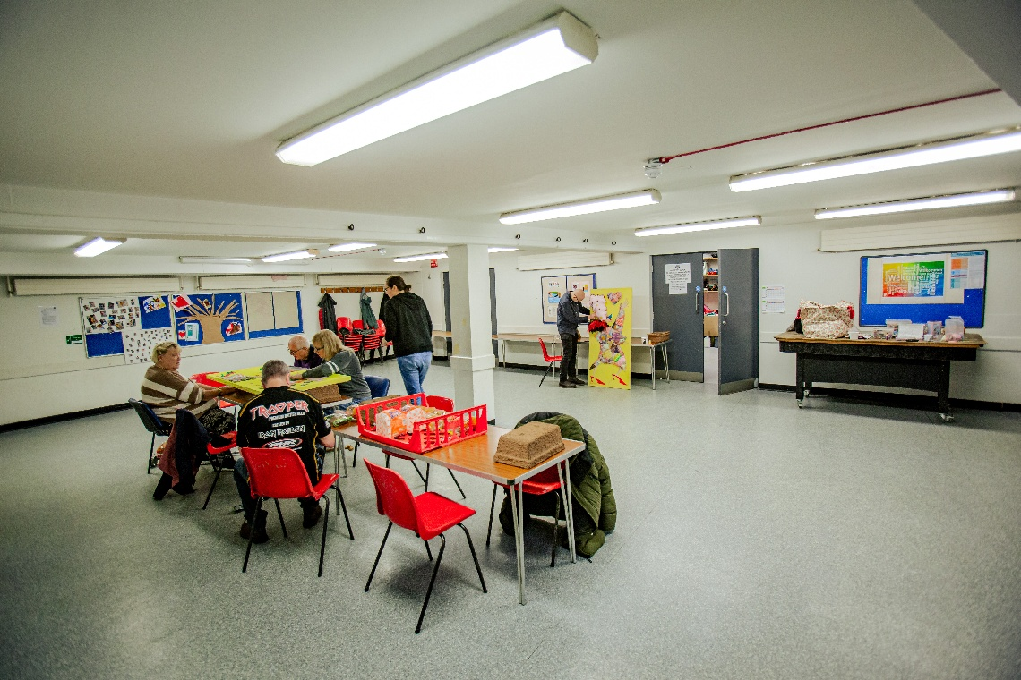
Facilitators
The class is facilitated by Richard Geddis and Sheelagh Colclough.
