Crescent Arts Centre
Address: 2-4 University Road, the Crescent Arts Centre is in the Botanic area of Belfast near Queens University.
Open Arts office number: 028 90 240765

L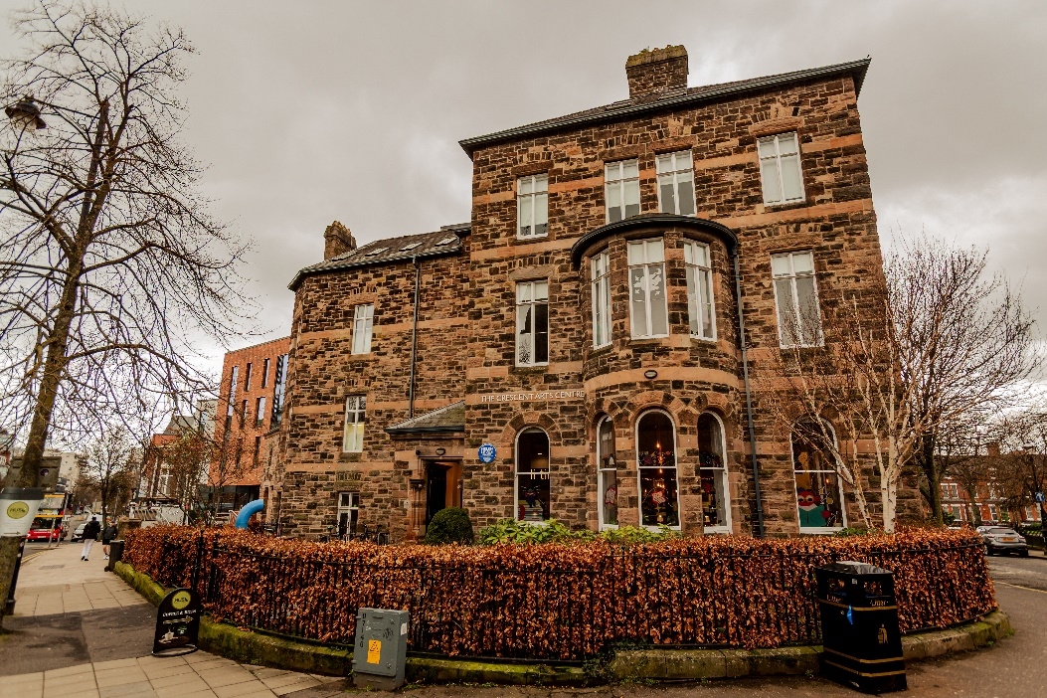
Getting Here
Train - Botanic train station is a 5 mins walk from the building.
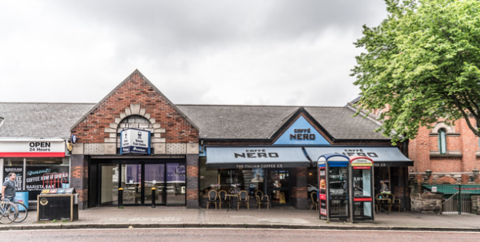
Metro Bus
Service number 7 - Ormeau Road & Stranmillis leaves from Howard Street.
Service number 8 - Malone Road & Stranmillis leaves Donegal Square East.
Car parking
There is limited on street parking. The closest public car park in Posnett Street, a 6 mins walk away. There are no disabled parking spaces on Lower Crescent, the road next to the Crescent Arts Centre building.

Entrance
Step free entrance through the front gate.
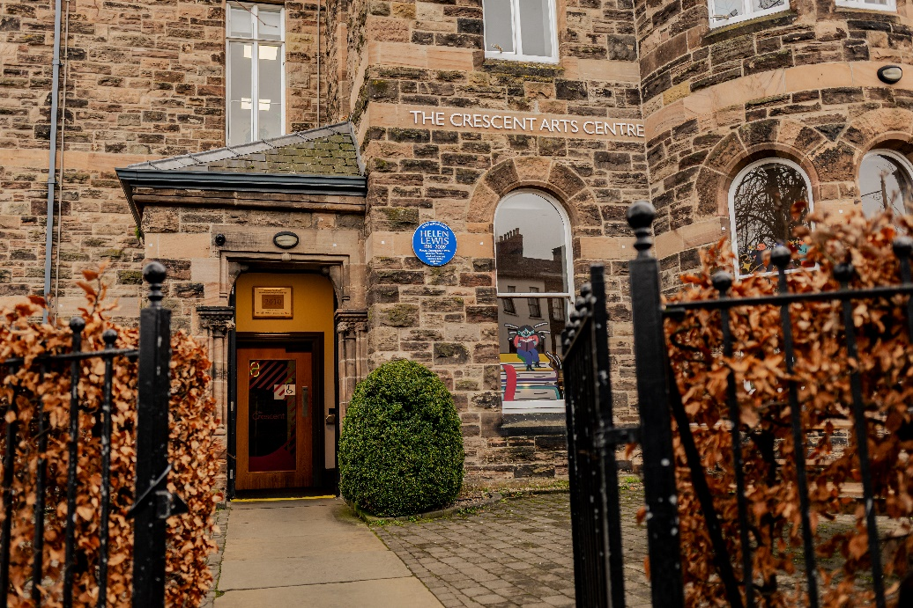
Reception
The reception is on the left when you enter the building
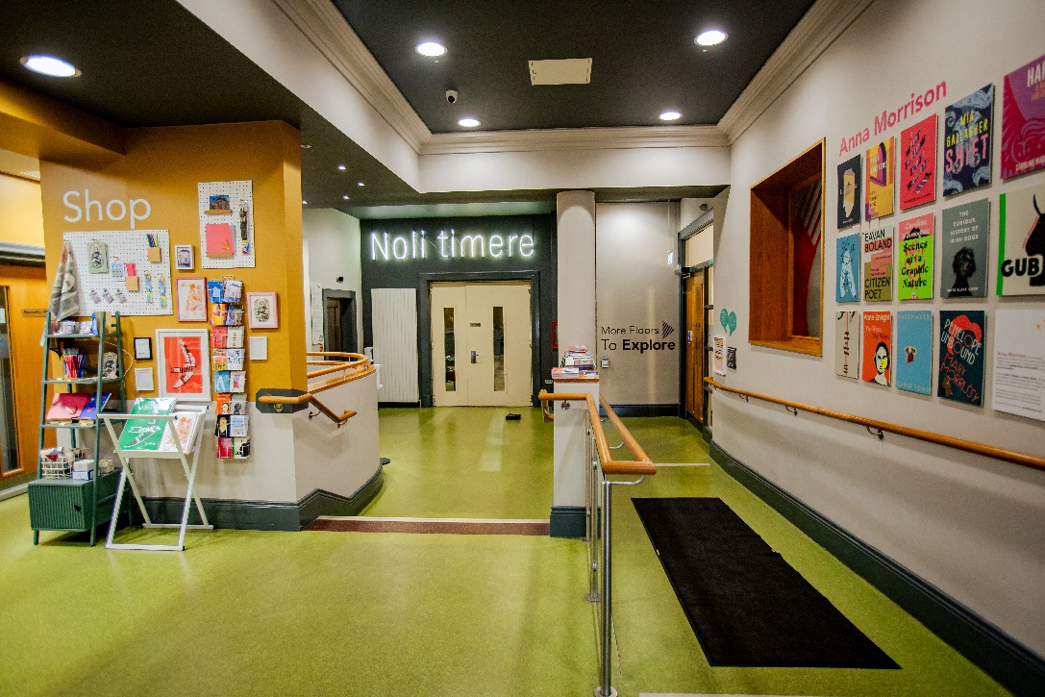
This is Clement, a member of the customer service team. He will answer any questions and offer help. Other staff are also available.
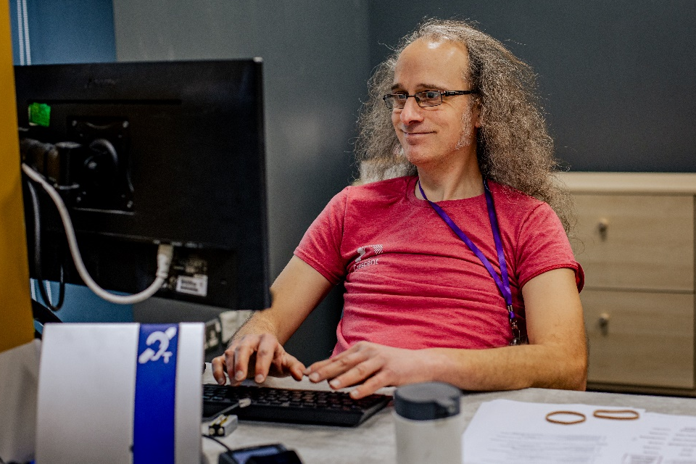
Access Facilities
- Push button access for automatic doors in most of the building.
- Portable loop system.
- Basic wheelchair available on request.
- Ear plugs.
- Free sanitary products in the female toilets.
- Baby changing facilities in both female and male toilets with free nappies and wipes.
- Changing place toilet.
Cafe
Café Husk is on the ground floor.

Opening Hours:
Monday – Thursday 9am-8pm
Friday – Saturday 9am – 4pm
Sunday - Closed

The café doesn’t serve hot food after 3pm.
They take cash and card payments.
It can get noisy when it is busy.

Toilets
There are accessible toilets on all three levels of the building.
Ground Floor – Gender neutral and a changing place toilet. The changing place toilet is opened using a radar key. If you do not have one, you can get one at reception.

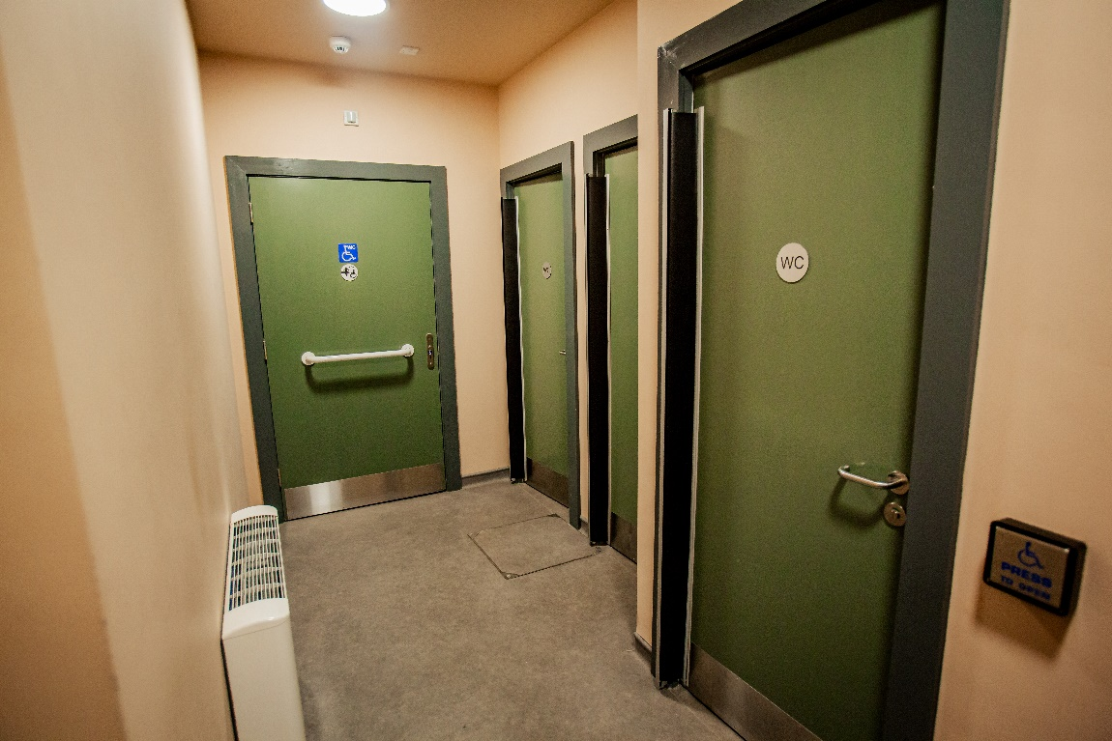
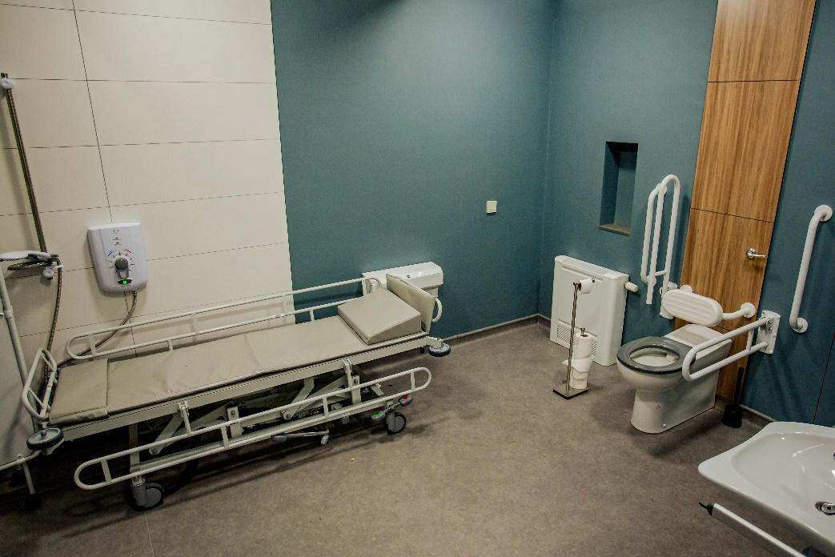

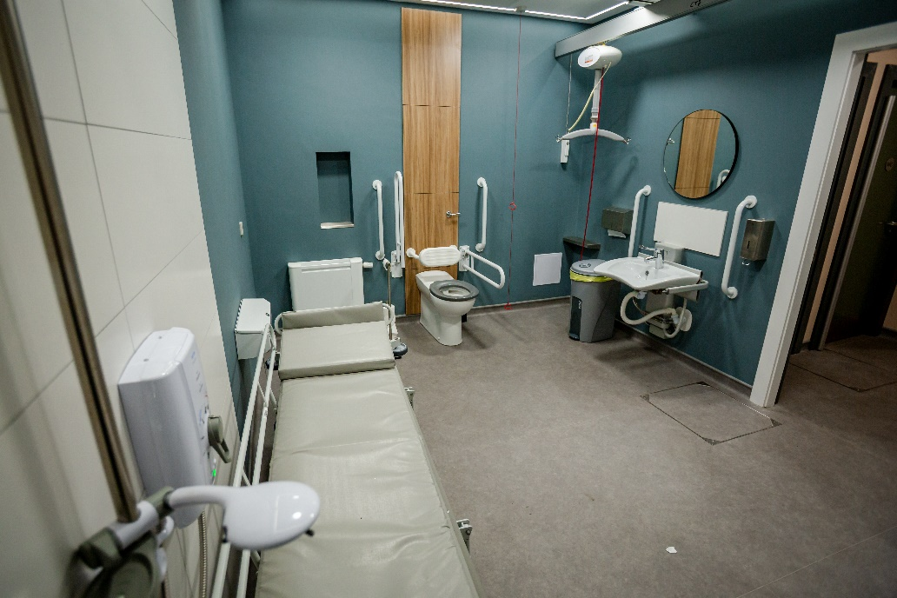
1st Floor toilets – Men and accessible
2nd Floor toilets – Women and accessible
3rd Floor toilets – Accessible only

Open Arts Office
Our office is located on the second floor, which is accessed via the stairs or lift. It is a colourful room with lots of artwork on the walls. It’s a great place for participants, artists and staff to socialise.
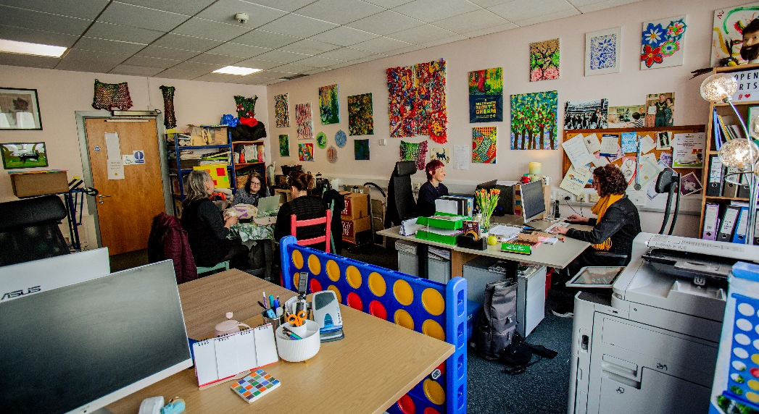

Open Arts staff
Eileen Branagh – Chief Executive Officer
Email: Eileen@openartsni.org
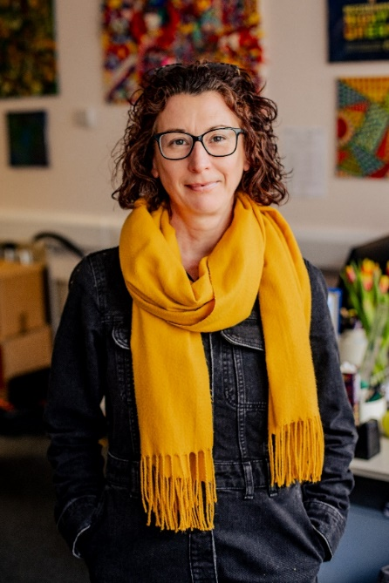
Jemma Robinson – Finance & Programme Officer
Email: Jemma@openartsni.org
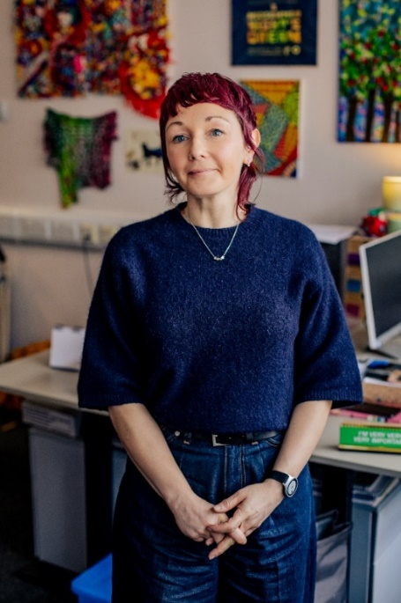

Mark Cousins – Communications & Development Assistant
Email: mark@openartsni.org
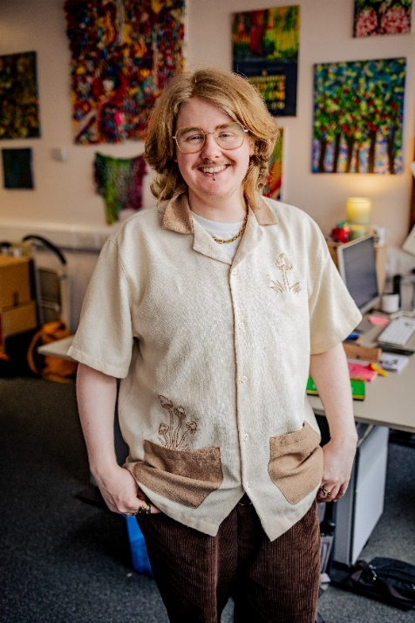
Classes
Open Arts offers creative classes throughout the week. Below is information on each class and the facilitators involved. For more details, please contact jemma@openartsni.org

Visual Art – Monday & Wednesday
When: Visual art meets weekly on Monday, 10:30am-12:30pm and Wednesday 10am-12pm.
Where: Workshop 1, located on the first floor. It can be accessed via main staircase or lift located in reception.
Workshop 1 room:
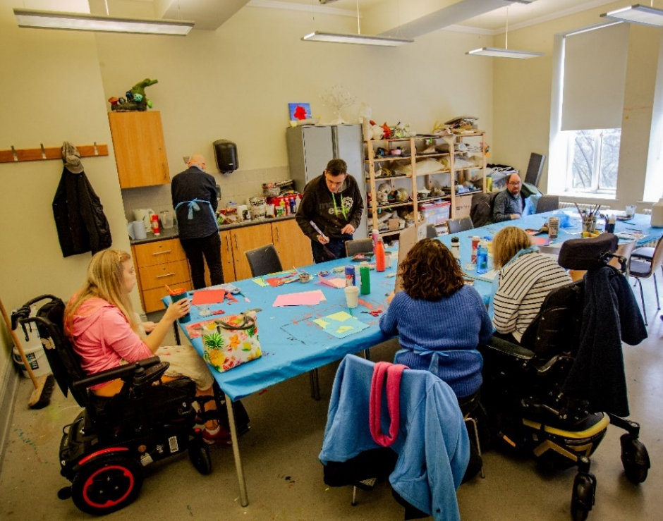
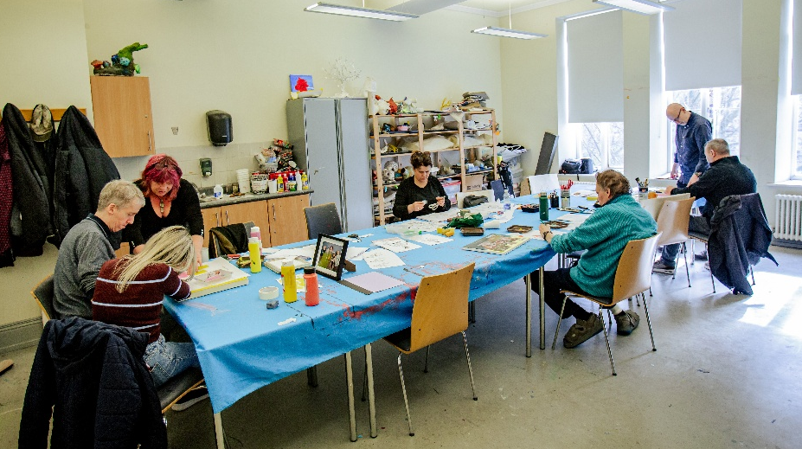
Facilitators
Visual Art - Monday is facilitated by Sheelagh Colclough and Richard Geddis. It is sometimes supported by a volunteer.
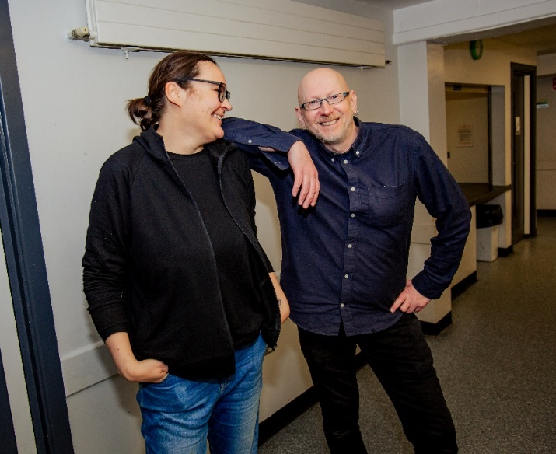
Visual Art - Wednesday is facilitated by Richard Geddis and Anne Marie Taggart pictured below.
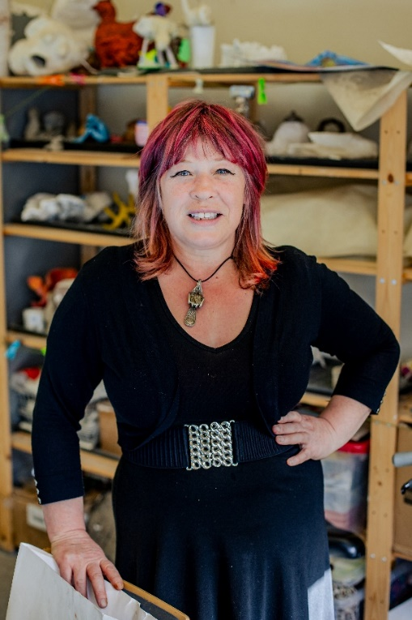

Monday Players Drama
When: Monday Players Drama meets weekly on Monday, 2pm-4pm.
Where: The David Hill Studio, located on the ground floor.
The David Hill Studio room:
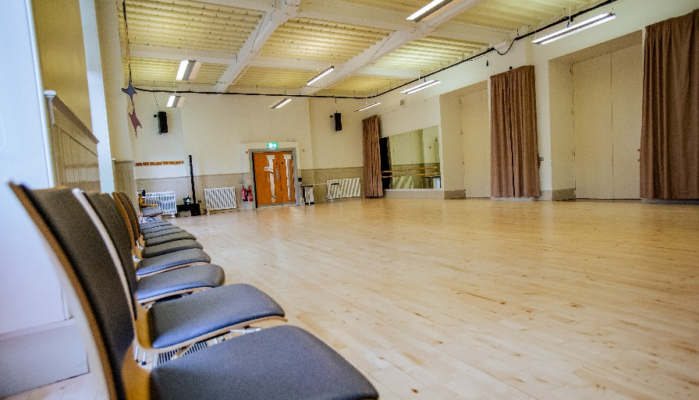
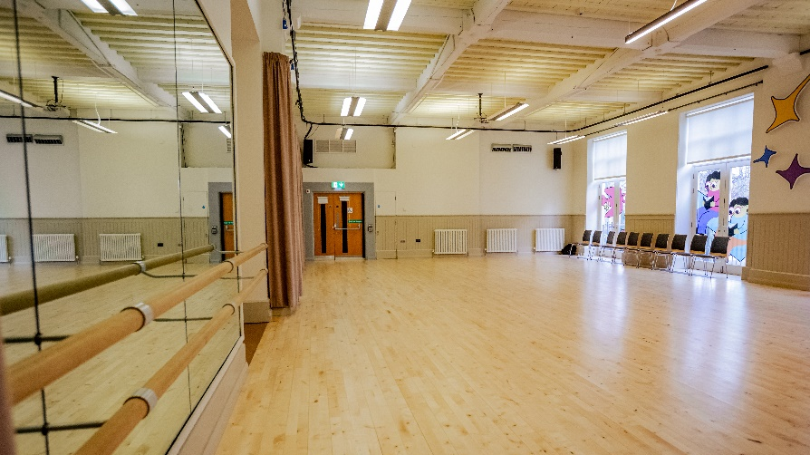
Facilitators
The class is facilitated by Stephen Beggs and Orla McKeagney.
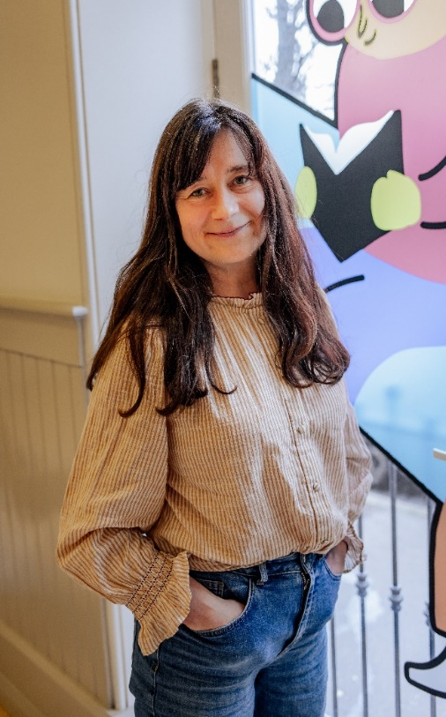
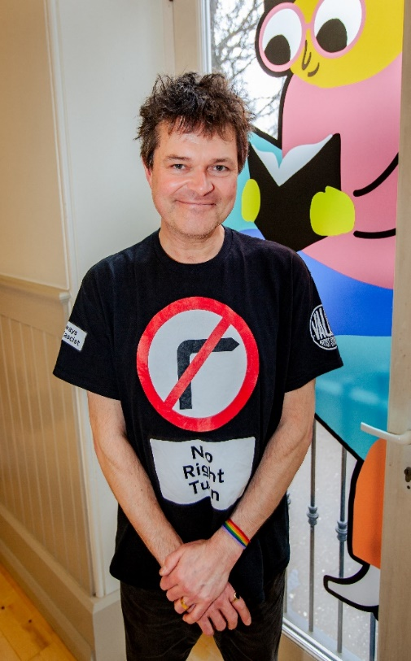

Open Pen - Creative writing group*
When: Weekly on a Wednesday 2pm-3:30pm.
Where: The Language room, located on the second floor. The class can be accessed via main staircase or lift located in reception.
*Please note this is a hybrid class. This means you can attend in-person or online via Zoom. Online participants will be visible on a large screen TV in class.
The Language room:
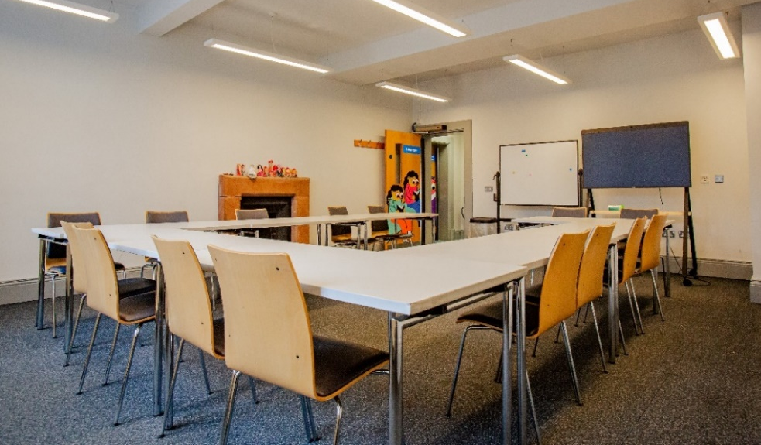
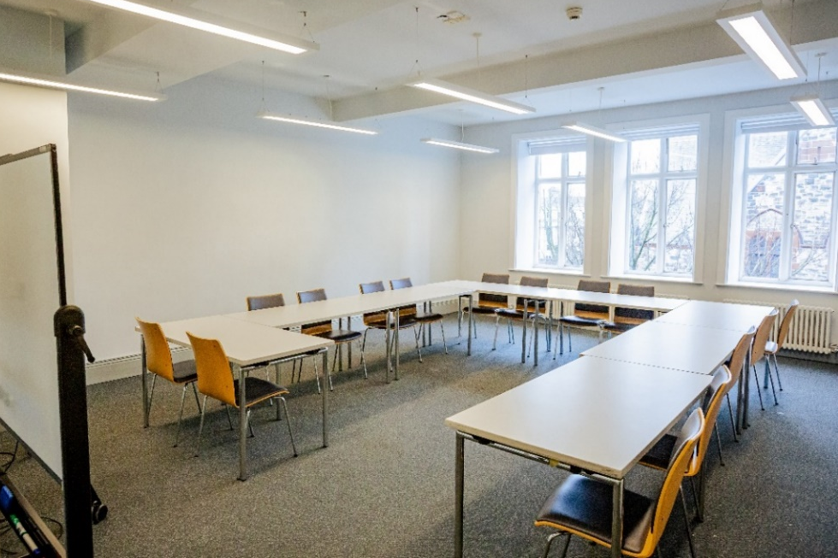
Facilitator
The class is facilitated by Natasha Cuddington.
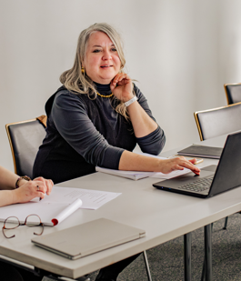
Luminous Soul Dance
When: Luminous Soul Dance meets weekly on Thursday 1pm-3pm.
Where: The David Hill Studio, which is located on the ground floor. It is sometimes held in the Helen Lewis Dance Studio which is located on the second floor and accessed via main staircase or lift located in reception.

The David Hill Studio room:
Facilitators
The class is facilitated by Helen Hall.
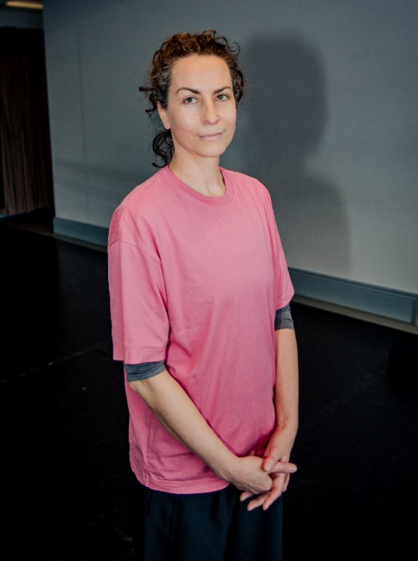
Arts Access Assistants
There is support available from Andy Paton and Leah Graham.
